EXP 1 : HUFFMAN CODING

Program 1:Calculation of average code length using Huffman Coding

P=[ ] // enter the probabilities

symbol= : // no of symbols

[dict,avglen]=huffmandict(symbol,P)

Program 2: Applying Huffman coding on a image

A=imread(' '); // enter the image nameor the directory

C=imhist(A); // plots the histogram but I only histogram asked the write **imhist(A)** only

p=C./numel(A);

symbol=1:256

[dict,avglen]=huffmandict(symbol,p)

EXP 2: EYE PATTERN

SEE VIDEo

EXP 3: READ All THE COMPONENTS

EXP 4:v configuration of web smtp ftp

Step 1: draw the circuit diagram consisting of 2811 router, 2 switches(2950-24), 2 pcs on each switch and 4 servers namely DNS,WEB,SMTP,FTP on one switch

Step 2: configure the ip of pc and put the default gateway as the ip of the router

Step 3: ip of router as:

en

config t

int fa0/0

ip address // ip address and subnet mask

no shut

exit

int fa0/1

ip address

no shut

exit

Step 4:

Use web ftp and email and ping the pcs

For ftp, write ftp address

EXP 5: BPSK

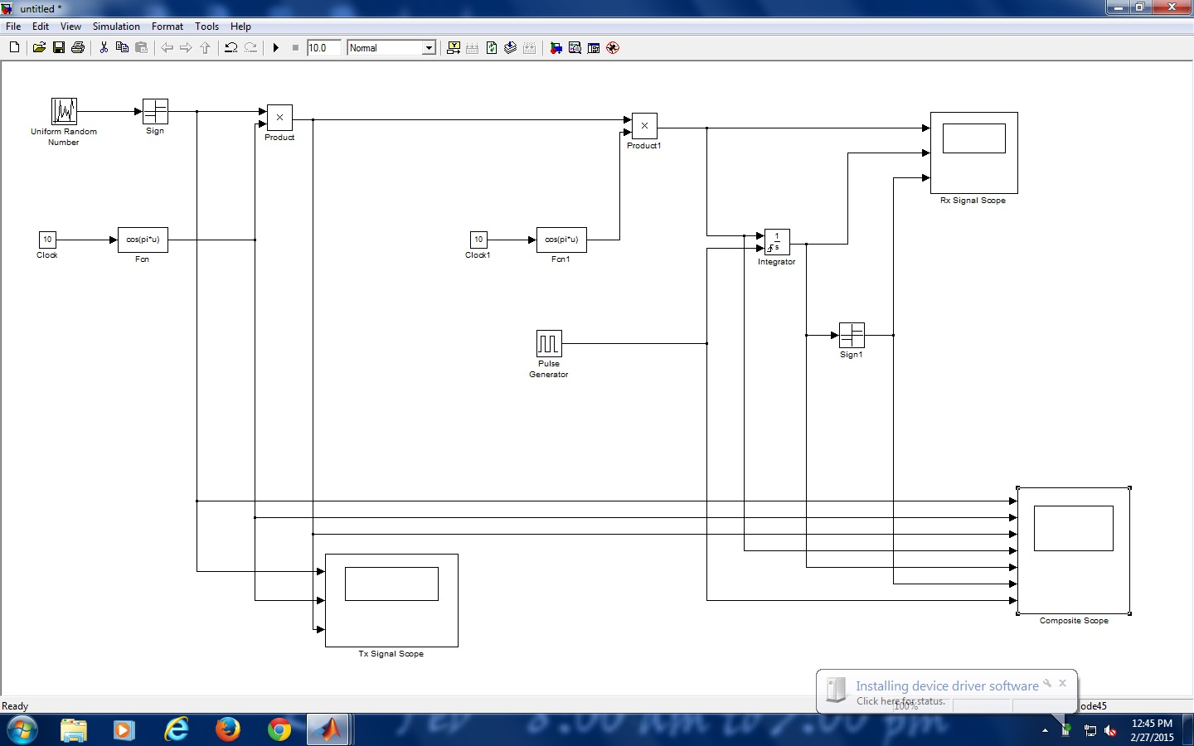

EXP 6: cyclic encoder

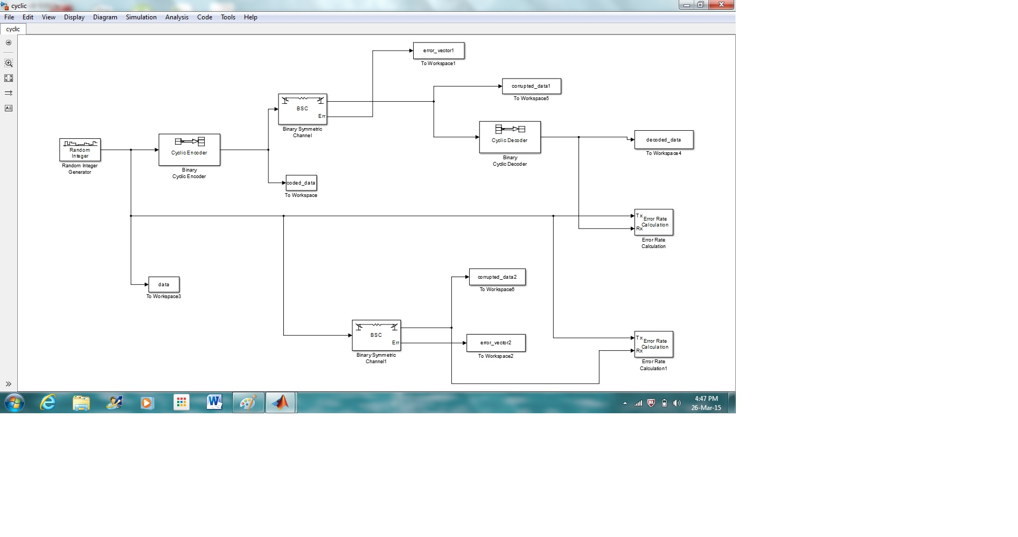

EXP 8: wire shark

Remember interface< start<filter packets<http,tcp,udp

http.recipes.com/1/2/cookies.php <http packets

http.recipes.com/1/2/forms.php <http packets

EXP 7: TELNET

EXP 9: Convolutional code

A.Transform Domain

syms D

g1=(1+D+D^2);

G1=sym2poly(1+D+D^2); % first generator matrix

syms D

g2=(1+D^2);

G2=sym2poly(1+D^2); % second generator matrix

syms D

m=(D^4+D^1+1);

M=sym2poly(m);

m=length(G1);

n=length(M);

l=length(G2);

X=[G1,zeros(1,n-1)];

H=[M,zeros(1,m-1)];

L=[G2,zeros(1,n-1)];

for i=1:n+m-1

Y1(i)=0;

Y2(i)=0;

for j=1:m

if(i-j+1>0)

a(i)=X(j)*H(i-j+1);

b(i)=L(j)*H(i-j+1);

Y1(i)=xor(Y1(i),a(i));

Y2(i)=xor(Y2(i),b(i));

else

end

end

end

Y1 %first encoded seq

Y2 %second encoded seq

B. Time Domain

G1=input('Enter generator matrix one: ');

G2=input('Enter generator matrix two: ');

M=input('Enter message bits: ');

m=length(G1);

n=length(M);

l=length(G2);

X=[G1,zeros(1,n-1)];

H=[M,zeros(1,m-1)];

L=[G2,zeros(1,n-1)];

for i=1:n+m-1

Y1(i)=0;

Y2(i)=0;

for j=1:m

if(i-j+1>0)

a(i)=X(j)*H(i-j+1);

b(i)=L(j)*H(i-j+1);

Y1(i)=xor(Y1(i),a(i));

Y2(i)=xor(Y2(i),b(i));

else

end

end

end

Y1 %first encoded sequence

Y2 %second encoded sequence

Enter generator matrix one: [1 1 1]

Enter generator matrix two: [1 0 1]

Enter message bits: [1 0 0 1 1]

EXP 10: FIREWALL